**EXISTING SYSTEM:**

The review paper [18] discusses the research works inresponding to learners’ affective states. In this section,we focus on the systems (ITS and Educational games)which detect and address the students’ affective states while they interact with the system. We describe five such systems in this section.. To study the effect of three types of responses to frustration – ignore students’ frustration, collect feedback from students, and provide messages – an affect-support. computer game [4], induces frustration by freezing the screen when the students play the game. The first type “Ignore students’ frustration” provides no motivational messages and does not collect feedback from the users.The second type “Collect feedback” collects the studentfeedback in terms of how they feel, but and does not provide any motivational messages. In the third type, the system provides feedback messages and sympathy messages

whenever the user reports frustration. The impactof responses provided to the students was analyzed using data from 71 students. Students’ frustration is identified by self-reporting using questionnaires. According to the reported analysis, students felt significantly less frustrated when playing the game without freezing than the game playing with freezing. The students who got feedback message and empathy messages played the game for significantly more time than the students who got no messages implying that responding to frustration

by providing motivation has an impact on students’frustration.

**DISADVANTAGES:**

* It is not secured process.
* Over under traction is invents
* Download files, time is invited

**PROPOSED SYSTEM:**

In this subsection, we describe the step 8 in Figure 2 ofour approach, that is the algorithm to display motivational messages. For the events listed in Table 2, that is for each goal failure, we show the messages based on the student’s response time in answering the questions from Mindspark, and question type. We restrict the number of messages per Mindspark session to three. This is to limit the number of interventions to the students during their interaction with Mindspark and avoid students not to focus on feedback messages. The algorithm to display a message based on frustration instance is shown in The condition to display messages for second and third instances of frustration is described in the algorithm 1. In next section we describe the research design and impact of motivational messages provide to students. To determine the impact of the motivational messages, we use the within-groups research design (repeated measures) that is comparing the results of our approach to responding to frustration against a control condition.

The experimental condition is that students receive motivational messages based on our proposed model and schools were chosen to represent different cities in India have minimum 100 class 6 students. The theoretical model to detect frustration was developed using data from class six students, hence we collected the data of class six student from three schools. We collected data from 769 class six students, 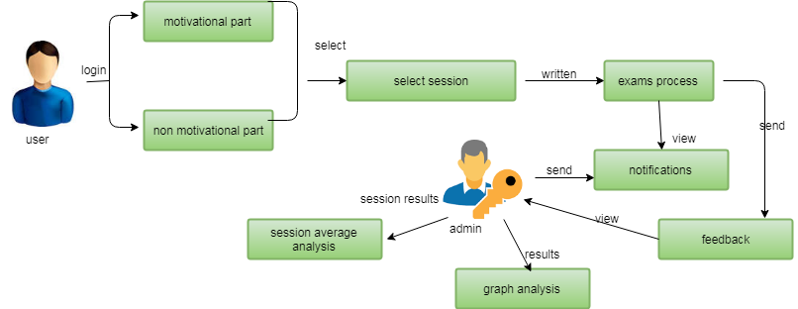

**ADVANTAGES**

* Compelling and relevant content will grab the attention of potential customers and increase brand visibility
* You can respond instantly to industry developments and be seen as ‘thought leader’ or expert in your field. This can improve how your business is seen by your audience.
* Positive feedback is public and can be persuasive to other potential customers.
* Negative feedback highlights areas where you can improve.